**TOUCHNET – Online Account Information**

In order for a parent or other bill payer to view student billing information or make payments online, **the student must first enter their parent(s) or other bill payer as an authorized user(s) through the student online site**.

**Adding an Authorized User in TouchNet**

1. Log in to **myTAYLOR**.
2. Open the **Student tab**.
3. Click on the **TouchNet – Online Billing & Payments (Busar’s Office)** tile.

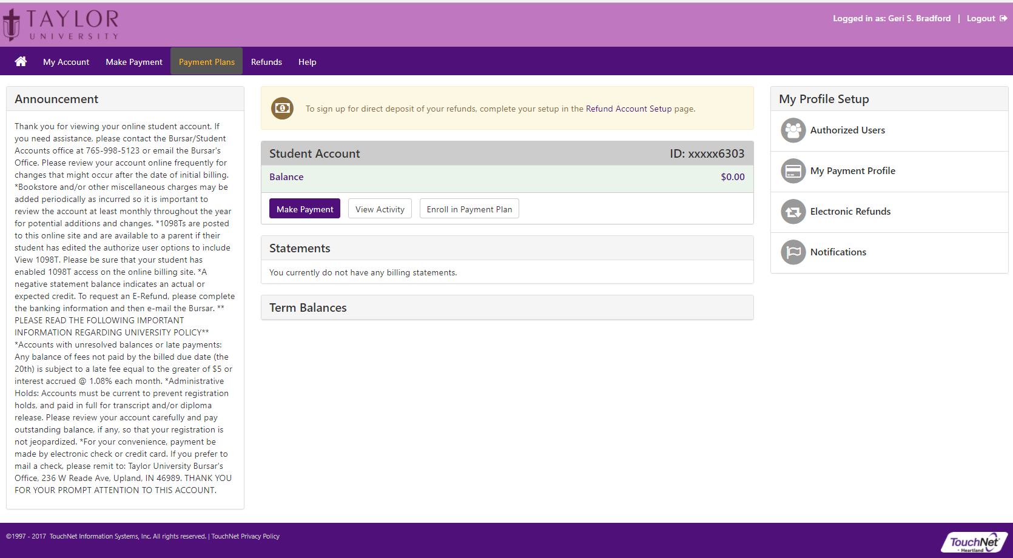

1. Click on **Authorized Users** located in the upper right corner of the page under **My Profile Setup**.

From the **Authorized Users** page, you can give others (parents, employers, etc.) the ability to access your account information. In compliance with the Family Educational Rights and Privacy Act of 1974 (FERPA), your student financial records may not be shared with a third party without your written consent. Adding an authorized user is your written consent that an individual may view your account information and make payments on your behalf.

Please note that authorized users DO NOT have access to your stored payment methods, academic records, or other personal information.

A list of current authorized users will be displayed. 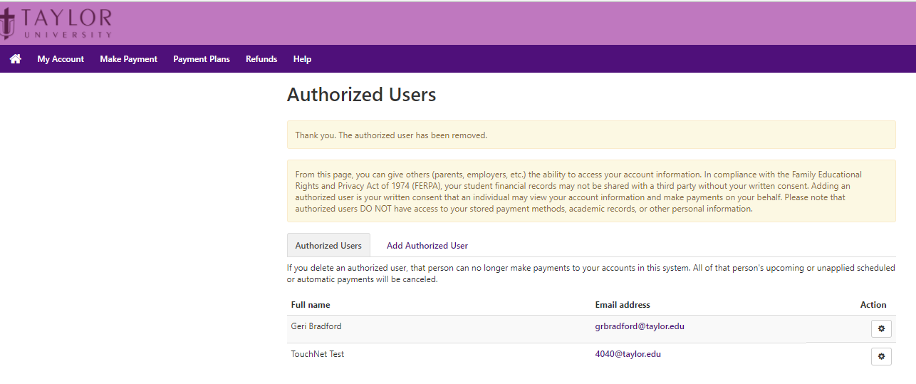

1. Click on **Add Authorized User** to add a new user.
2. Enter the email address of the authorized user.
3. Select the financial information your authorized users should be able to access.
4. Click **Continue**

